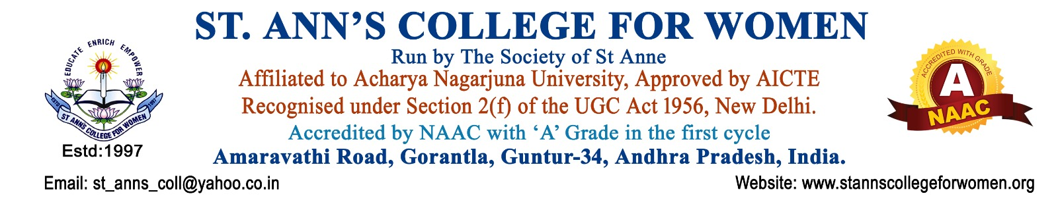

Equal Opportunity Cell (EOC) & SC/ST/OBC/Minority Cell
Committee Guidelines & Procedures
The Equal Opportunity Cell (EOC) & SC/ST/OBC/Minority Cell of St. Ann’s College for Women is constituted to ensure equality, social justice, inclusiveness, and empowerment of students belonging to SC, ST, OBC, Minority, economically weaker, and differently-abled categories in accordance with UGC regulations, NAAC quality mandates, APSCHE norms, and Government policies.
The Cell works to create a campus atmosphere free from discrimination and promotes equal access to education, opportunities, welfare schemes, and institutional support services.
Objectives
- To promote equality, social justice, and inclusiveness among all students.
- To ensure a discrimination-free campus environment irrespective of caste, religion, community, language, disability, or socio-economic background.
- To safeguard the rights and interests of SC/ST/OBC/Minority and differently-abled students.
- To create awareness about constitutional rights, government welfare schemes, scholarships, and educational opportunities.
- To provide academic, emotional, and institutional support to marginalized and underprivileged students.
- To encourage participation of all students in academic, co-curricular, extension, leadership, and placement activities.
- To address grievances related to discrimination, exclusion, or unequal treatment.
- To support the implementation of reservation policies and inclusive education practices.
- To maintain institutional harmony, diversity, and equal participation in campus life.

Composition of the Committee
The Committee shall consist of:
- Principal – Chairperson
- Senior Faculty Member – Coordinator
- Faculty Representatives
- SC/ST/OBC/Minority Representatives
- Women Faculty Representatives
- Differently-Abled Support Representative (if available)
- Student Representatives
- Administrative Staff Member
The tenure of the committee shall normally be one academic year or as decided by the institution.
Roles and Responsibilities
Equal Opportunity & Inclusion
- Promote equal opportunities in academics, sports, cultural activities, leadership roles, and institutional participation.
- Ensure fair treatment and equal access to institutional facilities for all students.
- Foster mutual respect, tolerance, and social harmony within the campus.
Welfare & Student Support
- Guide eligible students regarding scholarships, fee reimbursements, hostels, fellowships, and government welfare schemes.
- Assist students in applying for state and central government scholarships.
- Provide mentoring and counseling support for disadvantaged students.
- Support differently-abled students by facilitating accessible learning environments and necessary academic assistance.
Awareness & Capacity Building
- Organize awareness programs on constitutional rights, social justice, gender equality, inclusiveness, and anti-discrimination laws.
- Conduct seminars, workshops, guest lectures, orientation programs, and outreach activities related to equal opportunity and social empowerment.
- Observe important days related to social justice, constitutional values, and empowerment initiatives.
Grievance Redressal
- Receive complaints relating to discrimination, harassment, exclusion, or denial of opportunities.
- Maintain confidentiality while addressing grievances.
- Recommend suitable corrective and disciplinary measures to the Principal whenever necessary.
- Ensure prompt and fair resolution of grievances.
Institutional Compliance
- Ensure implementation of UGC regulations and Government reservation policies.
- Coordinate with IQAC and college administration for inclusive practices and NAAC documentation.
- Maintain records of beneficiaries under various welfare schemes and support programs.
Procedures
Formation of Committee
- The Principal shall constitute the EOC & SC/ST/OBC/Minority Cell at the beginning of every academic year.
- Roles and responsibilities shall be communicated to all members officially.
Meetings
- The committee shall meet at least twice in a semester or as required.
- Minutes of meetings shall be recorded and maintained properly.
Awareness Programs
- Conduct orientation programs for newly admitted students regarding scholarships, welfare schemes, and equal opportunity provisions.
- Organize awareness campaigns on anti-discrimination policies and constitutional rights.
Student Support Process
- Identify eligible students requiring academic, financial, or emotional support.
- Guide students in submitting scholarship applications and necessary documents.
- Facilitate counseling, mentoring, and remedial support whenever required.
Complaint Handling Procedure
- Complaints may be submitted in written or online form to the committee coordinator.
- The committee shall review complaints confidentially and conduct necessary inquiry.
- Appropriate recommendations shall be submitted to the Principal for action.
- Records of complaints and resolutions shall be maintained securely.
Documentation & Reporting
The committee shall maintain:
- Committee constitution records
- Meeting minutes
- Circulars and notices
- Attendance of programs conducted
- Reports of awareness activities
- Scholarship and beneficiary records
- Grievance records and action taken reports
- Annual activity report with photographs and supporting documents
Expected Outcomes
- Promotion of equality and inclusiveness on campus.
- Increased awareness among students regarding rights and welfare schemes.
- Enhanced support for socially and economically disadvantaged students.
- Improved access to scholarships and government benefits.
- Creation of a discrimination-free and harmonious institutional environment.
- Strengthened compliance with UGC, NAAC, APSCHE, and Government norms.
Conclusion
The Equal Opportunity Cell (EOC) & SC/ST/OBC/Minority Cell of St. Ann’s College for Women, Gorantla, is committed to upholding the principles of equality, dignity, inclusiveness, and social justice. The Cell strives to create an empowering educational environment where every student receives equal opportunities for academic growth, personal development, and holistic progress irrespective of social or economic background.

